STUDENT PLACEMENT DECLARATION FORM - SEPTEMBER 2022 BATCH

Name of the C-DAC Course | PG Diploma in Advanced Computing (PG-DAC)
Name of the Student | Pranav Dattatray Desai
Student ID | 220940320080

C-DAC’s Common Campus Placement Programme (CCPP) Guidelines
- Students are instructed to attend the CCPP in formals during campus placement processes.
- Students should be ready for the recruitment process 30 minutes prior to the given scheduled start of the process.
- Only those students who are on the shortlist of the company are permitted to participate in the recruitment process of that company.
- Students are advised to keep their mobile phones on silent mode during the whole recruitment process.
- Students are strictly prohibited from contacting (except during the pre-placement talk) company representatives for any information.
- Strict action will be taken against students found indulging in any kind of cheating/ indisciplinary activity during the campus placement process. If any student is found to be involved in malpractices, he/she will be temporarily suspended from CCPP for 15 calendar days. The student will be permanently debarred from CCPP if he/she is found to be involved in malpractices for the second time.
- During placement, students can opt out from a maximum of 5 companies only. In such cases, the students have to email (in advance) the request for opting out to their centre's Placement Officer. Only then their decision to opt-out will be considered. The opted out company will, however, be considered as a chance and added in the student's list of attempted companies.
- If not opted out in writing, it is compulsory for the students to attend all the processes of the shortlisted company. Withdrawing from a company midway through its process may lead to expulsion from CCPP.
- Students will be allowed to appear for the recruitment process of UP TO a maximum 30 companies for which they are eligible as per the company’s shortlisting criteria.
- Leaves are considered only for cases of serious and prolonged illness of the student. Medical certificate from a government doctor is to be submitted to C-DAC to get the leave approved.
- Without opting-out or taking approved leave, if any student does not attend the process on his/ her campus day for any reason, he/she will be temporarily suspended from CCPP for 10 calendar days. The student will be permanently debarred from CCPP if he/she is absent for the second time.
- Students once selected on campus will not be allowed to appear through CCPP for any other company and will be automatically out of the CCPP.
- In case of parallel (concurrent) recruitment processes, students will have to select the company whose offer is declared first to C-DAC.
- Students are advised to contact their centre's Placement Officer, if there is a discrepancy in the offers made to them compared to what published in the Campus Notice.
- Dr CP Johnson, Chief Placements Officer (CPO) of C-DAC Mumbai Region reserves the right to amend any of the above-mentioned guidelines for the benefit of the students, without any prior notice.
By signing this, I declare that I have read and understood C-DAC placement guidelines and will abide by them.

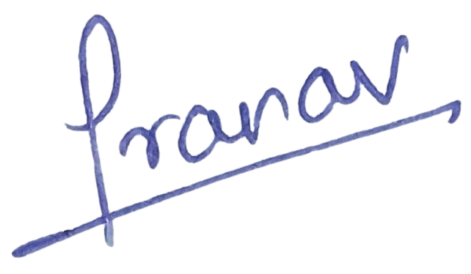
Signature of the Student: Date: 13 March 2023

